**Mini Project report**

***on***

CR HOTEL

**Under the guidance of:**

Ms. Akanksha Puri

***by***

Rahul Aggarwal(IIITU17332)

B.Tech (IT)



**Indian Institute of Information Technology**

**Una, Himachal Pradesh**

**ACKNOWLEDGEMENT**

I would like to express my immense gratitude to Ms. Akanksha Puri. Without her help this project would not have been realized. I would like to thank her for her continuous support at every step and pushing me to my limits. I would also like to express my appreciation for the help received from my team members Mr. Chandan Kumar and Mr. Rahul Aggarwal. I would like to thank for spending time on reading my report and giving me valuable inputs on my project.

I have taken efforts in this project. However, it would not have been possible without the kind support and help of many individuals and organizations. I would like to extend my sincere thanks to all of them.

I am highly indebted to Ms. Akanksha Puri for their guidance and constant supervision as well as for providing necessary information regarding the project & also for their support in completing the project.

My thanks and appreciations also go to my colleague in developing the project and people who have willingly helped me out with their abilities.

**CONTENTS**

* Introduction 5
* Technologies used 7
* Front end
* Back end
* Coding 8-29
* Screenshots of the code
* Screenshots of the output
* Conclusion 30
* References 31

**ABSTRACT**

The goal of our mini project is to design a Hotel Website. The languages used for the development of this project are HTML, JAVASCRIPT and CSS. The project file contains assets such as scripts, animations, images and many more. CR Hotel is an E-commerce website specially designed for PCs. As a result, we have created hotel website that help the customer to book the comfortable rooms at lowest price.

The knowledge and understanding of quality standards of guests helps hotel managers improve the quality of hotel services and increase guests’ satisfaction with the hotel stay. Different aspects of a hotel offer participate in the guests’ evaluation of the hotel experience. There exist a large number of factors that influence guests’ impressions, but certainly not all of them have the same level of importance for guests. In order to be aware of the strengths and weaknesses of their businesses, hotel CR has to identify which improvements in the hotel operations can bring additional value to their guests. One of the most reliable information sources for gaining customer knowledge is undoubtedly the feedback provided directly from customers. The environment in which hospitality businesses operate nowadays has become radically connected to the use of the Internet. An increase in the usage of Social Media triggered extreme changes in the information channels that hotel guests use in order to make booking decisions. Hence, the CR hotel should be aware that travel information websites present a valuable source of information about customer preferences. They offer service providers a possibility to have an insight into the reasons for satisfaction or disappointment of their guests.

The aim of this report is to examine the relationship between different hotel attributes and the guests’ overall satisfaction with the hotel stay. It tries to uncover the most influential hotel attributes for the formation of guests’ satisfaction. The results of this research indicate that the attribute “service” has the greatest influence on customer satisfaction with the hotel stay. In addition, it is suggested that the way a service is provided has more influence on the satisfaction than some physical aspects of the hotel stay. Moreover, the value received for the price paid is perceived as a factor that influences the satisfaction of guests, regardless of the star category of a hotel.

**INTRODUCTION**

**CR Hotel Website**

We presented Machine Learning and Sentiment Word Net based method for opinion mining from hotel reviews and sentence relevance score based method for opinion summarization of hotel reviews. The classified and summarized hotel review information helps web users to understand review contents easily in a short time. Opinion Mining for Hotel Review system that detects hidden sentiments in feedback of the customer and rates the feedback accordingly. The system uses opinion-mining methodology in order to achieve desired functionality. Opinion mining for hotel reviews is a web application, which gives review of the feedback that is posted by various users. The system takes review of various users, based on the opinion, system will specify whether the posted hotel is good, bad, or worst. Based on users search on hotels, recommendations will be shown to the user based on how many times a user visited that particular hotel page. We use a database of sentiment based keywords along with positivity or negativity weight in database and then based on these sentiment keywords mined in user review is ranked. Once the user login to the system he views the hotels and gives review about the hotel. System will use database and will match the review with the keywords in database and rank the review accordingly. System will rate the hotel based on the rank of review. The role of the admin is to post new hotel and add keywords in database. This application is useful for those who are exploring new places and also useful for those who travel often. Using this application, a user will get to know which hotel is best and suitable for them. User can decide which hotel to accommodate before they reach the place.

* **Software Requirements:**
* Windows 7 or above
* Notepad
* Php
* **Advantages:**
* This system is useful for those people who visit new places quite

often.

* People can easily decide whether the hotel is good or bad by using

this application.

* Using Collaborative filtering, user will get recommendations of

hotels.

* Since system ranks the feedback based on the weight age of the

keywords in database, so the result is appropriate.

* User can decide which hotel to accommodate before they reach the

place.

* **Disadvantages:**
* System will match the opinion with those keywords which are in database rest of the words are ignored by the system.
* It may provide inaccurate results if data entered incorrectly.
* **Application:**
* This application also works as an advertisement, which makes many

people aware about the hotel.

* This application is also useful for the users who travel around the

country.

**TECHNIQUES USED**

* Front End

For the front end frame work, mainly HTML. HTML is used to give basic design to the game.

* Back End

For the back end programming, p5.js and p5.play is used. For creating graphic and interactive experiences p5.js is used. It is a JavaScript library that starts with the original goal of [Processing](http://processing.org/)—to make coding accessible for artists, designers, educators, and beginners—and reinterprets this for today's web. A full set of drawing functionality comes with p5.js, using the original metaphor of a software sketchbook. p5.js also has [add-on libraries](http://p5js.org/libraries/) that make it easy to interact with other HTML5 objects, including text, input, video, webcam, and sound. p5.js is a new interpretation, not an emulation or port, and it is in active development. And p5.play is a [p5.js](http://p5js.org/) library for the creation of games and playthings.**p5.play** provides a [Sprite](http://molleindustria.github.io/p5.play/examples/index.html?fileName=sprite.js) class to manage visual objects in [2D space](http://molleindustria.github.io/p5.play/examples/index.html?fileName=sprite4.js) and features such as [animation support](http://molleindustria.github.io/p5.play/examples/index.html?fileName=sprite3.js), [basic collision detection](http://molleindustria.github.io/p5.play/examples/index.html?fileName=collisions.js) and [resolution](http://molleindustria.github.io/p5.play/examples/index.html?fileName=collisions4.js), sprite [grouping](http://molleindustria.github.io/p5.play/examples/index.html?fileName=sprite8.js), helpers for mouse and keyboard [interactions](http://molleindustria.github.io/p5.play/examples/index.html?fileName=keyPresses.js), and a [virtual camera](http://molleindustria.github.io/p5.play/examples/index.html?fileName=camera.js). The game running in the background was made with **p5.play** and it's about 100 lines of code. Check all the [examples/tutorials](http://molleindustria.github.io/p5.play/examples/index.html).**p5.play** extends **p5.js**, a JavaScript library (and a community) that aims to make coding accessible for artists, designers, educators, and beginners. **p5.play** is built for accessibility and simplicity, not performance. It is designed to be understood and possibly modified by intermediate programmers.

**CODING**

**HOME PAGE:**

<!DOCTYPE html5>

<html>

<head>

<title> CR HOTEL</title>

<link rel="stylesheet" href="https://use.fontawesome.com/releases/v5.4.2/css/all.css" integrity="sha384-/rXc/GQVaYpyDdyxK+ecHPVYJSN9bmVFBvjA/9eOB+pb3F2w2N6fc5qB9Ew5yIns" crossorigin="anonymous">

<style>

.back{/*width:100%;

height: 100%;*/

position: relative;

background: url('abc.jpg');

background-size:100% 100%;

background-repeat: no-repeat;}

.navbar>div>div{float: left;

color:white;

font-size: 15px;

font-family: body;

/*padding-left: 30px;

padding-top: 20px;

padding-bottom: 20px;

padding-right: 30px;*/

margin-top: 20px;

margin-left: 30px;

padding: 10px;

overflow: hidden;

}

.navbar>div>div:hover{color:lightblue;

background-color: white;}

#log{margin-left: 60%}

#center{/*background-color: red;*/

height: 2.5%;

width: 18%;

position: absolute;

margin-top: 33%;

margin-left: 40%;

border: 3px solid white;

border-radius: 10px;

text-align: center;

color: white;

overflow: hidden;

}

#time{height: 20%;

width: 30%;

position: absolute;

margin-top: 40%;

font-size: 100px;

font-family: sans-serif;

overflow: hidden;

color: white;

}

#kdate{height:2%;

width: 30%;

position: absolute;

margin-top: 47%;

font-size: 18px;

font-family: sans-serif;

padding-left: 20px;

overflow: hidden;

color: white;

}

#center>span{font-size: 18px;

font-family: sans-serif;}

</style>

<script type="text/javascript">

function updateTime() {

var currentTime = new Date();

var hours = currentTime.getHours();

if(hours>12)

hours=hours-12;

var minutes = currentTime.getMinutes();

var curmonth = currentTime.getMonth();

var dispdate=currentTime.getDate();

var dispyear=currentTime.getYear();

var dday=currentTime.getDay();

dispyear+=1900;

//curmonth=curmonth+1;

if (minutes < 10){

minutes = "0" + minutes;

}

/* if (seconds < 10){

seconds = "0" + seconds;

}*/

var v = hours + ":" + minutes + " ";

if(hours < 11){

v+="PM";

} else {

v+="AM"

}

var dispmonth;

var array=['JANUARY','FEBRUARY','MARCH','APRIL','MAY','JUNE','JULY','AUGUST','SEPTEMBER','OCTOBER','NOVEMBER','DECEMBER'];

dispmonth=array[curmonth];

var array2=['SUNDAY','MONDAY','TUESDAY','WEDNESADY','THURSDAY','FRIDAY','SATURDAY'];

var dispday=array2[dday];

//dispmonth+=" "+dispdate;

dispdate+=" "+dispmonth+ " "+dispyear+ " " +dispday;

setTimeout("updateTime()",1000);

document.getElementById('time').innerHTML=v;

document.getElementById('kdate').innerHTML=dispdate;

}

function kddate(){

var d=new Date().toLocaleDateString();

}

updateTime();

</script>

</head>

<body class="back">

<div class="navbar">

<div>

<div id="hom"><i class="fas fa-home"></i> HOME</div>

<div>NEWS</div>

<div><i class="fas fa-phone fa-1x"></i> CONTACT US</div>

<div>OUR HOTELS</div>

<div id="log"><i class="far fa-user"></i> LOGIN</div>

</div>

</div>

<div id="center">

<span><b>BOOK NOW AND SAVE 20%</b></span>

</div>

<div id="time">

</div>

<div id="kdate"></div>

</body>

</html>

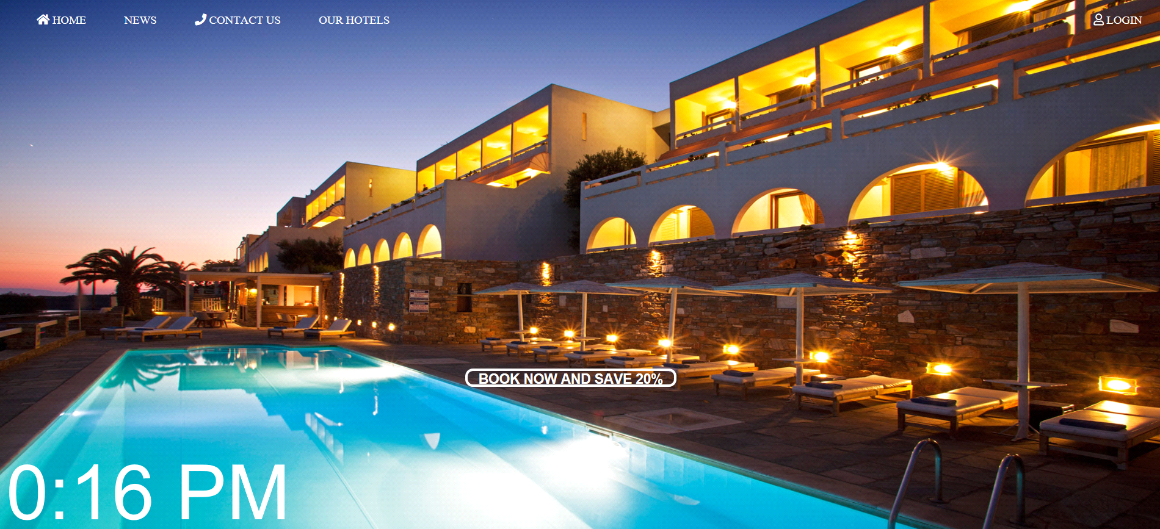

**LOGIN:**

<html>

<head>

<title>Login</title>

<meta charset="utf-8">

<style>

body

{ margin: 0;

padding: 0;

font-family: sans-serif;

background-image: url(abc.jpg);

background-repeat: no-repeat;

background-size: cover;

}

.login

{ width: 320px;

height: 420px;

background: orange;

color: #fff;

top: 50%;

left: 50%;

position: absolute;

transform:translate(-50%,-50%);

box-sizing:border-box;

padding: 70px 30px;

}

h1

{ margin: 0;

padding: 0 0 20px;

text-align: center;

font-size: 40px;

}

.login p

{ margin: 0;

padding: 0;

font-weight: bold;

}

.login input

{ width: 100%;

margin-bottom: 20px;

}

.login input[type="text"], input[type="password"]

{ border: none;

border-bottom: 2px solid red;

background: transparent;

outline: none;

color:green;

margin-top: 5px;

font-size: 16px

}

.login input[type="submit"]

{ border: none;

outline: none;

height: 40px;

background: green;

color: black;

font-size: 16px;

border-radius: 20px;

}

.login input[type="submit"]:hover

{ cursor: pointer;

background: red;

color:white;

}

.login a{

text-decoration: none;

font-size: 12px;

line-height: 20px;

}

.login a:hover

{ color:white;

}

.logo

{ width: 100px;

height: 100px;

border-radius: 50%;

position: absolute;

top: -50px;

left: 110;

}

.textbox

{ width: 100%;

overflow: hidden;

font-size: 20px;

padding:8px 0;

margin: 8px 0;

border-bottom: 2px solid;

}

</style>

</head>

<body>

<div class="login">

<img src="logo.svg" class="logo">

<h1>Login</h1>

<form onSubmit="myfunc()">

<p>Username</p>

<input type="text" id="1" placeholder="Enter username" value="">

<p>Password</p>

<input type="password" placeholder="password" value="">

<input type="submit" id="f"value="Login" onclick="myfunc()" ></button><br>

<a href="#">Forgot password?</a><br>

<a href="#">New User</a>

</form>

</div>

<p id="new"></p>

<script type="text/javascript">

function myfunc(){

var d=document.getElementById("1").value;

if(d=="RAHUL")

document.getElementById("new").innerHTML=d;

else

document.getElementById("new").innerHTML="INCORRECT";

}

</script>

</body>

</html>

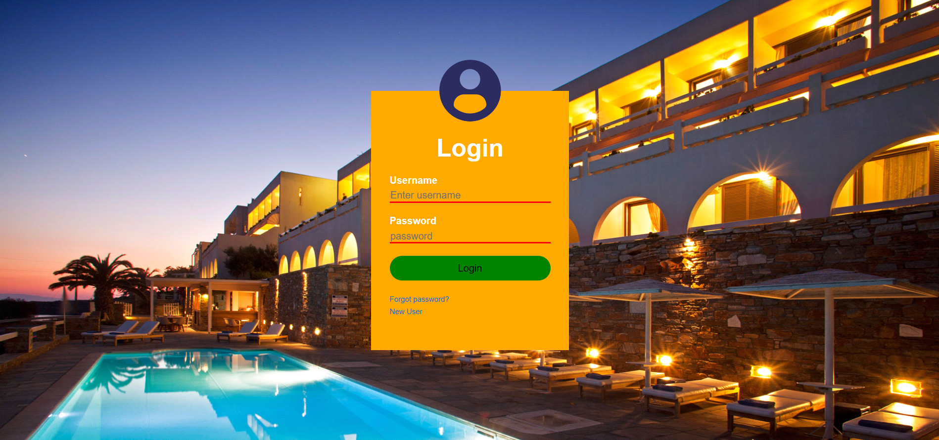

**RESERVATION:**

<html>

<head>

<title>Reservation Form</title>

<style>

body, html {

height: 110%;

margin: 0;

}

.bg-img{

/* The image used */

background-image: url("abc.jpg");

/* Full height */

height: 100%;

/* Center and scale the image nicely */

background-position: center;

background-repeat: no-repeat;

background-size: cover;

}

/* Position the navbar container inside the image */

.container {

position: absolute;

margin: 20px;

width: auto;

}

/* The navbar */

.topnav {

overflow: hidden;

background-color: rgba(255,255,255,0);

}

/* Navbar links */

.topnav a {

float: left;

color: #f2f2f2;

text-align: center;

padding: 14px 16px;

text-decoration: none;

font-size: 17px;

}

.topnav a:hover {

background-color: #ddd;

color: black;

}

.active{

background-color: #4CAF50;

color: white;

}

</style>

<div class="bg-img">

<div class="container">

<div class="topnav">

<a href="proje.html">Home</a>

<a href="login.html" target="_blank">Login</a>

<a href="contact.html" target="_blank">Contact Us</a>

<a class="active" href="reservation.html" target="_blank">Reservation</a>

<a href="about.html" target="_blank">About</a>

</div>

</div>

<br><br><br><br><br>

<div style="color:white;"><p><span>NOTICE: Per night charge Adults=$60 and Children(under 10)=$30</span></style>

</div>

<br><br>

<form action="input1.php" method="get" onSubmit="return validateForm();">

<div style="width: 400px;">

</div>

<div style="display: flex; padding-bottom: 18px;width : 450px;">

<div style=" margin-left : 4; margin-right : 1%; width : 49%;">First name<span style="color: red;"> *</span><br/>

<input type="text" id="data_2" name="data_2" style="width: 100%;" class="form-control"/>

</div>

<div style=" margin-left : 1%; margin-right : 0; width : 49%;">Last name<span style="color: red;"> *</span><br/>

<input type="text" id="data_3" name="data_3" style="width: 100%;" class="form-control"/>

</div>

</div><div style="padding-bottom: 18px; margin-left: 4;">Phone<span style="color: red;"> *</span><br/>

<input type="text" id="data_4" name="data_4" style="width : 200px;" class="form-control"/>

</div>

<div style="padding-bottom: 18px; margin-left: 4;">Email<span style="color: red;"> *</span><br/>

<input type="text" id="data_5" name="data_5" style="width : 200px;" class="form-control"/>

</div>

<div style="padding-bottom: 18px; margin-left: 4;">Arrival date<span style="color: red;"> *</span><br/>

<input type="text" id="data_6" name="data_6" style="width : 200px;" class="form-control"/>

</div>

<script src="https://cdnjs.cloudflare.com/ajax/libs/pikaday/1.4.0/pikaday.min.js" type="text/javascript"></script>

<link href="https://cdnjs.cloudflare.com/ajax/libs/pikaday/1.4.0/css/pikaday.min.css" rel="stylesheet" type="text/css" />

<script type="text/javascript">new Pikaday({ field: document.getElementById('data_6') });</script>

<div style="padding-bottom: 18px;color:white; margin-left: 4;">Departure date<span style="color: red;"> *</span><br/>

<input type="text" id="data_7" name="data_7" style="width : 200px;" class="form-control"/>

</div>

<script src="https://cdnjs.cloudflare.com/ajax/libs/pikaday/1.4.0/pikaday.min.js" type="text/javascript"></script>

<link href="https://cdnjs.cloudflare.com/ajax/libs/pikaday/1.4.0/css/pikaday.min.css" rel="stylesheet" type="text/css" />

<script type="text/javascript">new Pikaday({ field: document.getElementById('data_7') });</script>

<div style="padding-bottom: 18px;color:white; margin-left: 4;">Number of adults<span style="color: red;"> *</span><br/>

<input type="number" id="data_8" name="data_8" style="width : 200px;" class="form-control"/>

</div>

<div style="padding-bottom: 18px;color:white; margin-left: 4;">Number of children<br/>

<input type="number" id="data_9" name="data_9" style="width : 200px;" class="form-control"/>

</div>

<div style="padding-bottom: 18px;color:white; margin-left: 4;">Questions / Comments<br/>

<textarea id="data_10" false name="data_10" style="width : 450px;" rows="6" class="form-control"></textarea>

</div>

<div style="padding-bottom: 18px;"><input name="skip_Submit" value="Submit" type="submit"/>

<style="padding-bottom: 18px;"><input name="skip_Submit" value="Reset" type="reset"/></div>

<button type="button" onclick="myFunction()">Submit</button>

<p id="demo"></p>

</form>

</div>

</div>

<body>

<script type="text/javascript">

function validateForm() {

if (isEmpty(document.getElementById('data_2').value.trim())) {

alert('First name is required!');

return false;

}

if (isEmpty(document.getElementById('data_3').value.trim())) {

alert('Last name is required!');

return false;

}

if (isEmpty(document.getElementById('data_4').value.trim())) {

alert('Phone is required!');

return false;

}

if (isEmpty(document.getElementById('data_5').value.trim())) {

alert('Email is required!');

return false;

}

if (!validateEmail(document.getElementById('data_5').value.trim())) {

alert('Email must be a valid email address!');

return false;

}

if (isEmpty(document.getElementById('data_6').value.trim())) {

alert('Arrival date is required!');

return false;

}

if (isEmpty(document.getElementById('data_7').value.trim())) {

alert('Departure date is required!');

return false;

}

if (isEmpty(document.getElementById('data_8').value.trim())) {

alert('Number of adults is required!');

return false;

}

return true;

}

function isEmpty(str) { return (str.length === 0 || !str.trim()); }

function validateEmail(email) {

var re = /^([\w-]+(?:\.[\w-]+)*)@((?:[\w-]+\.)*\w[\w-]{0,66})\.([a-z]{2,15}(?:\.[a-z]{2})?)$/i;

return isEmpty(email) || re.test(email);

}

function myFunction(){

var x=document.getElementById("data_8").value;

var y=x*60;

var z=document.getElementById("data_9").value;

var w=z*30

var a=y+w;

var b=document.getElementById("data_6").value;

var c=document.getElementById("data_7").value;

var d=c-b;

var e=d*a;

document.getElementById("demo").innerHTML = e;

}

</script>

</body>

</head>

</html>

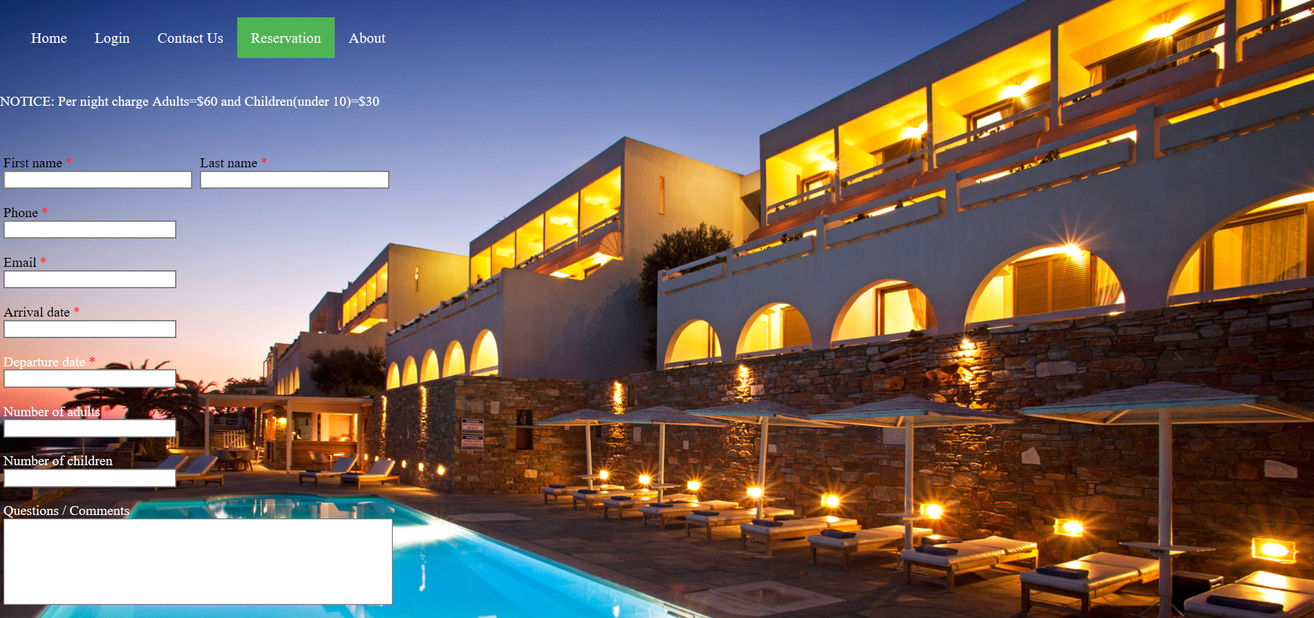

**CONTACT US:**

<!DOCTYPE html>

<html>

<head>

<title>Contact Us</title>

<meta name="viewport" content="width=device-width, initial-scale=1">

<style>

body, html {

height: 100%;

margin: 0;

}

.bg-img{

/* The image used */

background-image: url("1e.jpg");

/* Full height */

height: 100%;

/* Center and scale the image nicely */

background-position: center;

background-repeat: no-repeat;

background-size: cover;

}

/* Position the navbar container inside the image */

.container {

position: absolute;

margin: 20px;

width: auto;

}

/* The navbar */

.topnav {

overflow: hidden;

background-color: rgba(255,255,255,0);

}

/* Navbar links */

.topnav a {

float: left;

color: #f2f2f2;

text-align: center;

padding: 14px 16px;

text-decoration: none;

font-size: 17px;

}

.topnav a:hover {

background-color: #ddd;

color: black;

}

input[type=text], select, textarea {

width: 20%;

padding: 12px;

border: 1px solid #ccc;

border-radius: 4px;

box-sizing: border-box;

margin-top: 6px;

margin-bottom: 16px;

resize: vertical;

}

input[type=submit] {

background-color: #4CAF50;

color: white;

padding: 12px 20px;

border: none;

border-radius: 4px;

cursor: pointer;

}

input[type=submit]:hover {

background-color: #45a049;

}

.containr {

border-radius: 5px;

background-color: rgba(255,255,255,0);

padding: 20px;

}

.active{

background-color: #4CAF50;

color: white;

}

</style>

</head>

<body>

<form action="welcome.php" method="get" onsubmit="submt()">

<div class="bg-img">

<div class="container">

<div class="topnav">

<a href="proje.html">Home</a>

<a href="login.html" target="_blank">Login</a>

<a class="active" href="contact.html" >Contact Us</a>

<a href="reservation.html" target="_blank">Reservation</a>

<a href="about.html" target="_blank">About</a>

</div>

</div>

<br><br><br><br><h3><center><b>Fill in the details</b></center></h3>

<div class="containr">

<label for="fname">First Name</label><br>

<input type="text" id="fname" name="firstname" placeholder="Your name.."><br>

<label for="lname">Last Name</label><br>

<input type="text" id="lname" name="lastname" placeholder="Your last name.."><br>

<label for="country">Country</label><br>

<select id="country" name="country">

<option value="India">India</option>

<option value="canada">Canada</option>

<option value="usa">USA</option>

</select>

<br>

<label for="subject">Subject</label><br>

<textarea id="subject" name="subject" placeholder="Write something.." style="height:200px"></textarea>

<br>

<input type="submit" value="Submit">

<script>

function submt(){

alert("The form was submitted");

}

</script>

</form>

</div>

</div>

</body>

</html>

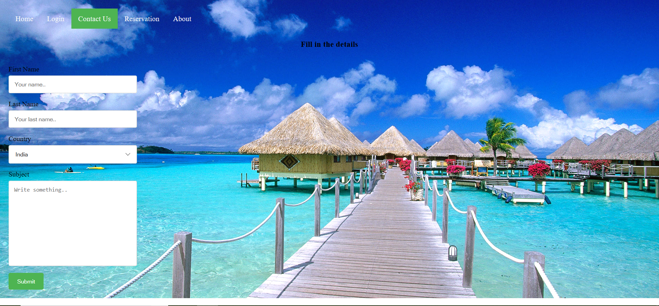

**OUR HOTEL:**

<html>

<head>

<title>OUR HOTEL</title>

<style type="text/css">

.ul1

{ margin-left:25%;

margin-top: 10%;

color: brown;

font-family: sans-serif;

float: left;

}

.ul2

{ margin-left:10%;

margin-top: 10%;

color: brown;

font-family: sans-serif;

float: left;

}

.ul3

{ margin-left:10%;

margin-top: 10%;

color: brown;

font-family: sans-serif;

float: left;

}

.a

{ padding: 20px;

}

.a:hover

{ color:yellow;

}

</style>

</head>

<body>

<center>

<ul type="none" class="ul1">

<li class="a"><a href="login1.html">New Delhi</a></li>

<li class="a"><a href="login1.html">Bihar</a></li>

<li class="a"><a href="login1.html">Lucknow</a></li>

<li class="a"><a href="login1.html">Prayag Raj</a></li>

<li class="a"><a href="login1.html">Balia</a></li>

</ul>

<ul type="none" class="ul2">

<li class="a"><a href="login1.html">Hyderabad</a></li>

<li class="a"><a href="login1.html">Noida</a></li>

<li class="a"><a href="login1.html">Bangalore</a></li>

<li class="a"><a href="login1.html">Kolkata</a></li>

<li class="a"><a href="login1.html">Chennai</a><li>

</ul>

<ul type="none" class="ul3">

<li class="a"><a href="login1.html">Hamirpur</a></li>

<li class="a"><a href="login1.html">Shimla</a></li>

<li class="a"><a href="login1.html">Una</a></li>

<li class="a"><a href="login1.html">Mumbai</a></li>

<li class="a"><a href="login1.html">Goa</a></li>

</ul>

</center>

</body>

</html>

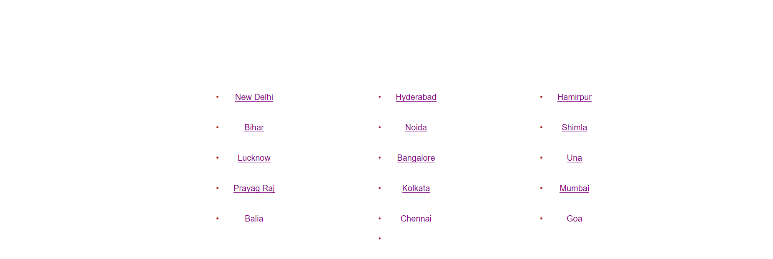

**CONCLUSION**

Hotel business is one of the upcoming businesses especially in the towns and cities of Assam. It is an outcome of the growth of mobility resulting from diversification of economic activity, transforming social attitude and gradually growing touristic activities. Though the hotel industry is at budding state in Assam, it constitutes an important segment of the tertiary sector. It plays a vital role in the economic life of a society, its potentialities for providing employment, promoting the growth of ancillary industrial activities through its broader linkage effects.

With the development of reliable transportation and associated rising income and standard of living, there has been a rise in the flow of tourists both domestic and foreign for different purposes to the state, so the need of hotels. As a result there has been a gradual rise in the total number of hotels and lodges with the corresponding rise in rooms and bed capacity in the accommodation sector in Assam. Fast and reliable transport system has influence in the development of tourism for a country or to a state and the quality of transport has a direct impact on hospitality sector.

**REFERENCES**

* <http://ieeexplore.ieee.org/document/5474286/>
* <http://ieeexplore.ieee.org/document/7129564/>
* [https://www.w3schools.com](https://www.w3schools.com/)
* [https://www.100forms.com](https://www.100forms.com/)